# **Boyer Moore Algorithm for Pattern Searching**

Pattern searching is an important problem in computer science. When we do search for a string in a notepad/word file, browser, or database, pattern searching algorithms are used to show the search results.

A typical problem statement would be-

” Given a text txt[0..n-1] and a pattern pat[0..m-1] where n is the length of the text and m is the length of the pattern, write a function search(char pat[], char txt[]) that prints all occurrences of pat[] in txt[]. You may assume that n > m. “  
**Examples:**

***Input:*** *txt[] = “THIS IS A TEST TEXT”*

*pat[] = “TEST”*

***Output:*** *Pattern found at index 10*

***Input:*** *txt[] = “AABAACAADAABAABA”*

*pat[] = “AABA”*

***Output:*** *Pattern found at index 0*

*Pattern found at index 9*

*Pattern found at index 12*

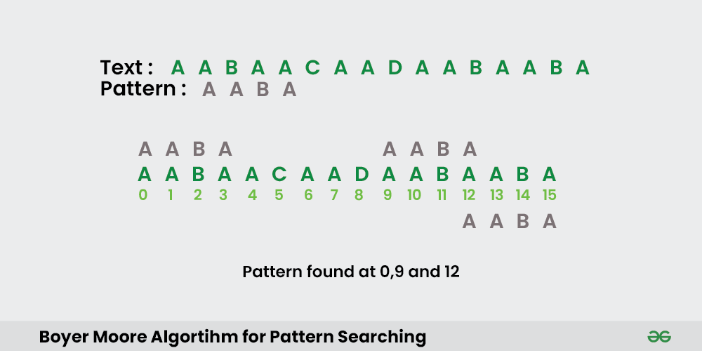

In this post, we will discuss the Boyer Moore pattern searching algorithm. Like [KMP](https://www.geeksforgeeks.org/kmp-algorithm-for-pattern-searching/) and [Finite Automata](https://www.geeksforgeeks.org/finite-automata-algorithm-for-pattern-searching/) algorithms, Boyer Moore algorithm also preprocesses the pattern.   
Boyer Moore is a combination of the following two approaches.

1. **Bad Character Heuristic**
2. **Good Suffix Heuristic**

Both of the above heuristics can also be used independently to search a pattern in a text. Let us first understand how two independent approaches work together in the Boyer Moore algorithm.

If we take a look at the [Naive algorithm](https://www.geeksforgeeks.org/naive-algorithm-for-pattern-searching/), it slides the pattern over the text one by one. [KMP algorithm](https://www.geeksforgeeks.org/searching-for-patterns-set-2-kmp-algorithm/) does preprocessing over the pattern so that the pattern can be shifted by more than one. The Boyer Moore algorithm does preprocessing for the same reason. It processes the pattern and creates different arrays for each of the two heuristics. At every step, it slides the pattern by the max of the slides suggested by each of the two heuristics. **So, it uses greatest offset suggested by the two heuristics at every step**.

Unlike the previous pattern searching algorithms, the **Boyer Moore algorithm starts matching from the last character of the pattern.**In this post, we will discuss the bad character heuristic and the Good Suffix heuristic in the next post.

### **Bad Character Heuristic**

The idea of bad character heuristic is simple. The character of the text which doesn’t match with the current character of the pattern is called the **Bad Character**. Upon mismatch, we shift the pattern until –

1. The mismatch becomes a match.
2. Pattern P moves past the mismatched character.

### **Case 1 – Mismatch become match**

We will lookup the position of the last occurrence of the mismatched character in the pattern, and if the mismatched character exists in the pattern, then we’ll shift the pattern such that it becomes aligned to the mismatched character in the text T.

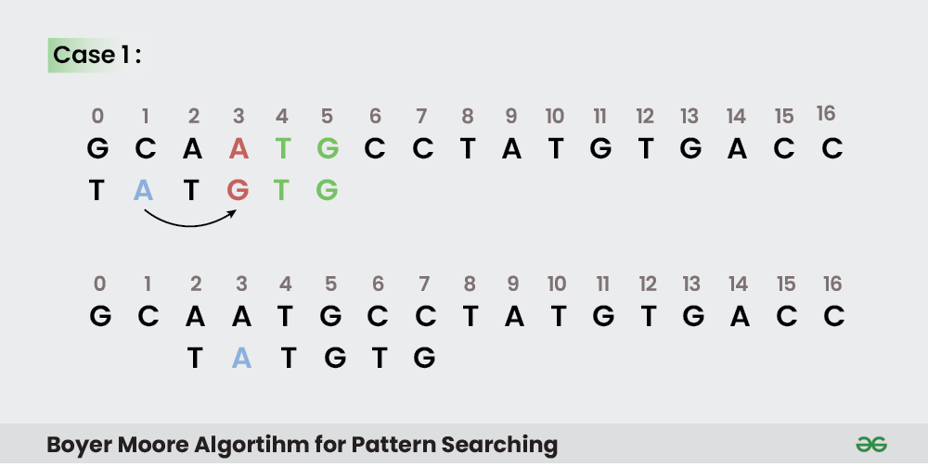

#### **Explanation:**

In the above example, we got a mismatch at position **3**.

Here our mismatching character is “A”. Now we will search for last occurrence of “A” in pattern. We got “A” at position 1 in pattern (displayed in Blue) and this is the last occurrence of it. Now we will shift pattern 2 times so that “A” in pattern get aligned with “A” in text.

### **Case 2 – Pattern move past the mismatch character**

We’ll lookup the position of last occurrence of mismatching character in pattern and if character does not exist we will shift pattern past the mismatching character.

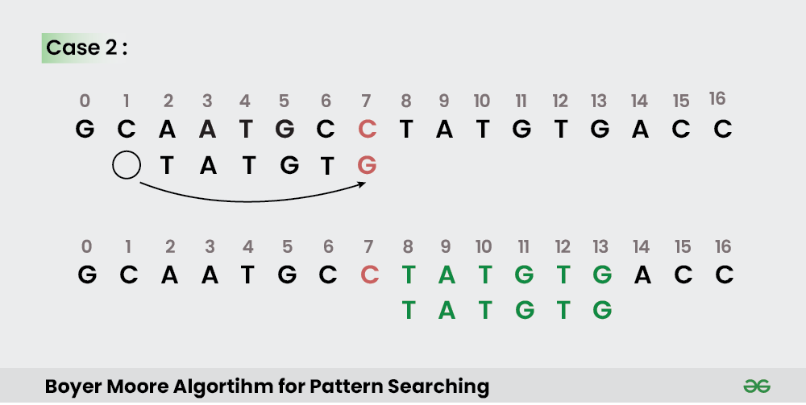

#### **Explanation:**

Here we have a mismatch at position **7**.

The mismatching character “C” does not exist in pattern before position 7 so we’ll shift pattern past to the position 7 and eventually in above example we have got a perfect match of pattern (displayed in Green). We are doing this because “C” does not exist in the pattern so at every shift before position 7 we will get mismatch and our search will be fruitless.

### **Implementation:**

In the following implementation, we pre-process the pattern and store the last occurrence of every possible character in an array of size equal to alphabet size. If the character is not present at all, then it may result in a shift by m (length of pattern). Therefore, the bad character heuristic takes O(n/m) time in the best case.

**Time Complexity :** O(m*n)

**Auxiliary Space:** O(1)

The Bad Character Heuristic may take **O(m*n)** time in worst case. The worst case occurs when all characters of the text and pattern are same. For example, txt[] = “AAAAAAAAAAAAAAAAAA” and pat[] = “AAAAA”. The Bad Character Heuristic may take O(n/m) in the best case. The best case occurs when all the characters of the text and pattern are different.

**Good Suffix Heuristic**

It is for pattern searching. Just like bad character heuristic, a preprocessing table is generated for good suffix heuristic.

Let

**t**

be substring of text

**T**

which is matched with substring of pattern

**P**

. Now we shift pattern until : 1) Another occurrence of t in P matched with t in T. 2) A prefix of P, which matches with suffix of t 3) P moves past t

**Case 1: Another occurrence of t in P matched with t in T**

Pattern P might contain few more occurrences of

**t**

. In such case, we will try to shift the pattern to align that occurrence with t in text T. For example-

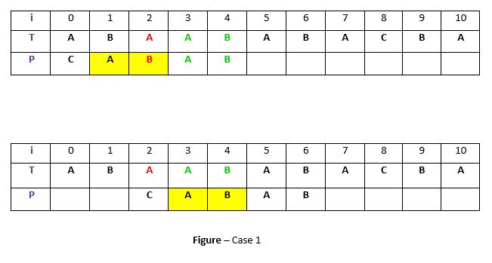

**Explanation:**

In the above example, we have got a substring t of text T matched with pattern P (in green) before mismatch at index 2. Now we will search for occurrence of t (“AB”) in P. We have found an occurrence starting at position 1 (in yellow background) so we will right shift the pattern 2 times to align t in P with t in T. This is weak rule of original Boyer Moore and not much effective, we will discuss a

**Strong Good Suffix rule**

shortly.

**Case 2: A prefix of P, which matches with suffix of t in T**

It is not always likely that we will find the occurrence of t in P. Sometimes there is no occurrence at all, in such cases sometimes we can search for some

**suffix of t**

matching with some

**prefix of P**

and try to align them by shifting P. For example –

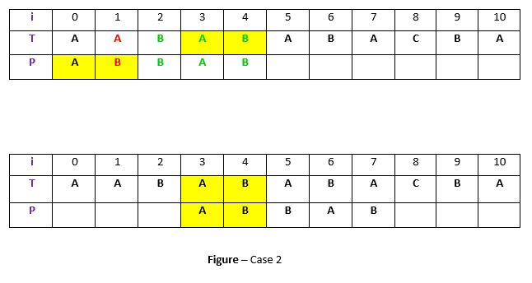

**Explanation:**

In above example, we have got t (“BAB”) matched with P (in green) at index 2-4 before mismatch . But because there exists no occurrence of t in P we will search for some prefix of P which matches with some suffix of t. We have found prefix “AB” (in the yellow background) starting at index 0 which matches not with whole t but the suffix of t “AB” starting at index 3. So now we will shift pattern 3 times to align prefix with the suffix.

**Case 3: P moves past t**

If the above two cases are not satisfied, we will shift the pattern past the t. For example –

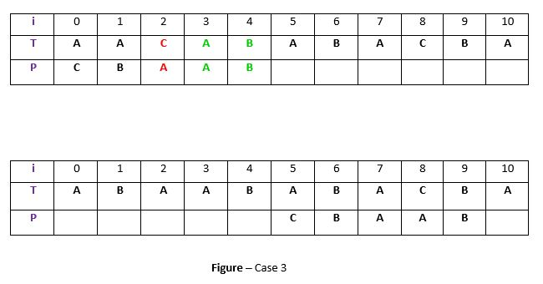

**Explanation:**

If above example, there exist no occurrence of t (“AB”) in P and also there is no prefix in P which matches with the suffix of t. So, in that case, we can never find any perfect match before index 4, so we will shift the P past the t ie. to index 5.

**Strong Good suffix Heuristic**

Suppose substring

**q = P[i to n]**

got matched with

**t**

in T and

**c = P[i-1]**

is the mismatching character. Now unlike case 1 we will search for t in P which is not preceded by character

**c**

. The closest such occurrence is then aligned with t in T by shifting pattern P. For example –

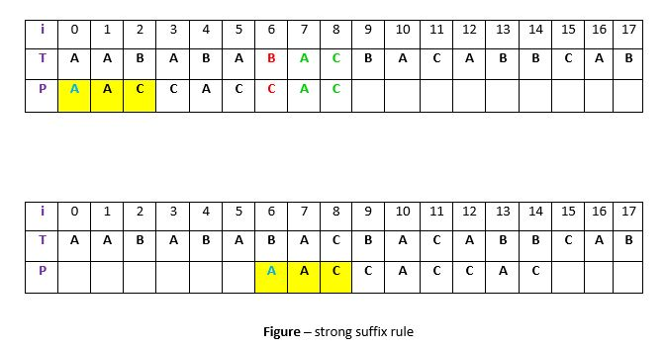

**Explanation:**

In above example,

**q = P[7 to 8]**

got matched with t in T. The mismatching character

**c**

is “C” at position P[6]. Now if we start searching t in P we will get the first occurrence of t starting at position 4. But this occurrence is preceded by “C” which is equal to c, so we will skip this and carry on searching. At position 1 we got another occurrence of t (in the yellow background). This occurrence is preceded by “A” (in blue) which is not equivalent to c. So we will shift pattern P 6 times to align this occurrence with t in T.We are doing this because we already know that character

**c = “C”**

causes the mismatch. So any occurrence of t preceded by c will again cause mismatch when aligned with t, so that’s why it is better to skip this.

**Preprocessing for Good suffix heuristic**

As a part of preprocessing, an array

**shift**

is created. Each entry

**shift[i]**

contain the distance pattern will shift if mismatch occur at position

**i-1**

. That is, the suffix of pattern starting at position

**i**

is matched and a mismatch occur at position

**i-1**

. Preprocessing is done separately for strong good suffix and case 2 discussed above.

**1) Preprocessing for Strong Good Suffix**

Before discussing preprocessing, let us first discuss the idea of border. A

**border**

is a substring which is both proper suffix and proper prefix. For example, in string

**“ccacc”**

,

**“c”**

is a border,

**“cc”**

is a border because it appears in both end of string but

**“cca”**

is not a border. As a part of preprocessing an array

**bpos**

(border position) is calculated. Each entry

**bpos[i]**

contains the starting index of border for suffix starting at index i in given pattern P. The suffix

**?**

beginning at position m has no border, so

**bpos[m]**

is set to

**m+1**

where

**m**